Ideation Phase
Brainstorm & Idea Prioritization Template

Date | 01 July 2026
Team ID
Project Name | STOCK TRADING APP
Maximum Marks | 4 Marks

Brainstorm & Idea Prioritization
Brainstorming was conducted to identify innovative project ideas that solve real-world problems using modern web technologies. Several ideas, including an Online Learning Platform, Hospital Management System, Food Delivery Application, Expense Tracker, and Stock Trading App, were discussed and evaluated based on their usefulness, feasibility, scalability, and technical implementation. After comparing all the ideas, the Stock Trading App was selected because it provides a practical learning environment for users to understand stock market trading without financial risk. The project allows users to securely register and log in, buy and sell stocks, manage their investment portfolio, track transaction history, and monitor profit or loss through an interactive dashboard. The idea was prioritized because it effectively demonstrates full-stack development using the MERN Stack, offers a clean and user-friendly interface, and has strong potential for future enhancements such as live stock price integration, watchlists, stock charts, AI-based investment recommendations, and mobile application support. Overall, the Stock Trading App was considered the most suitable solution due to its real-world relevance, scalability, and educational value.
Reference: https://www.mural.co/templates/brainstorm-and-idea-prioritization

Step-1: Team Gathering, Collaboration and Select the Problem Statement
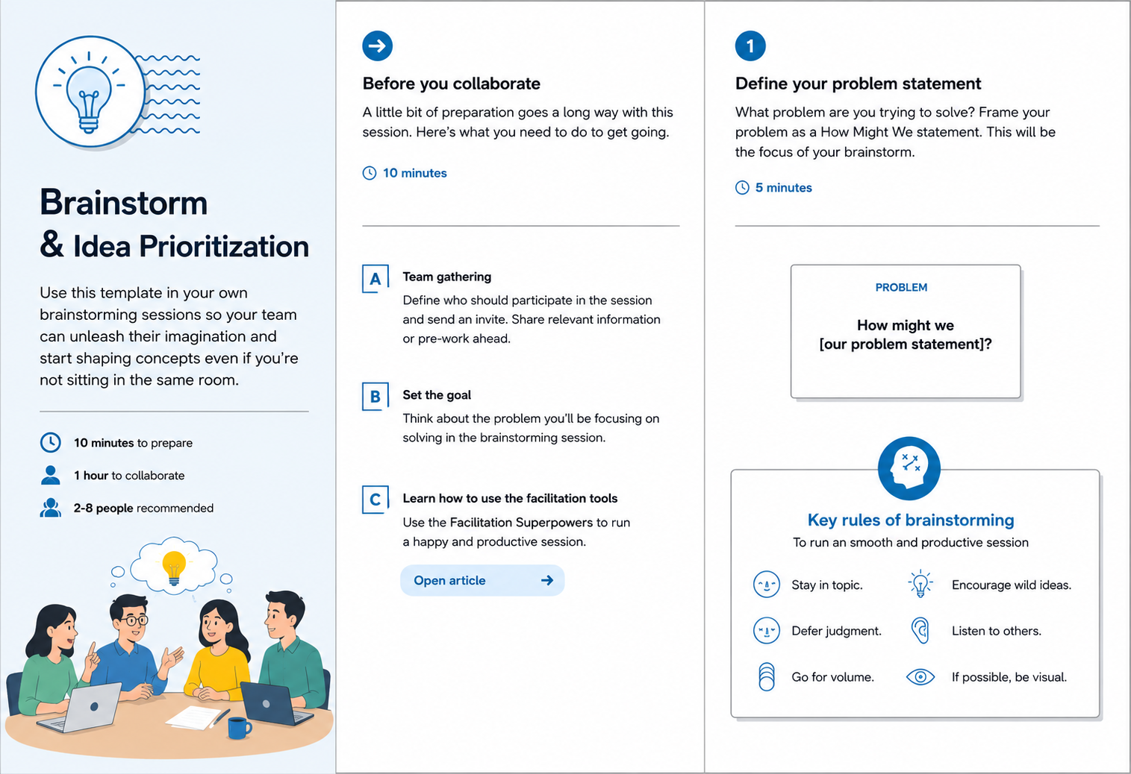

Step-2: Brainstorm, Idea Listing and Grouping
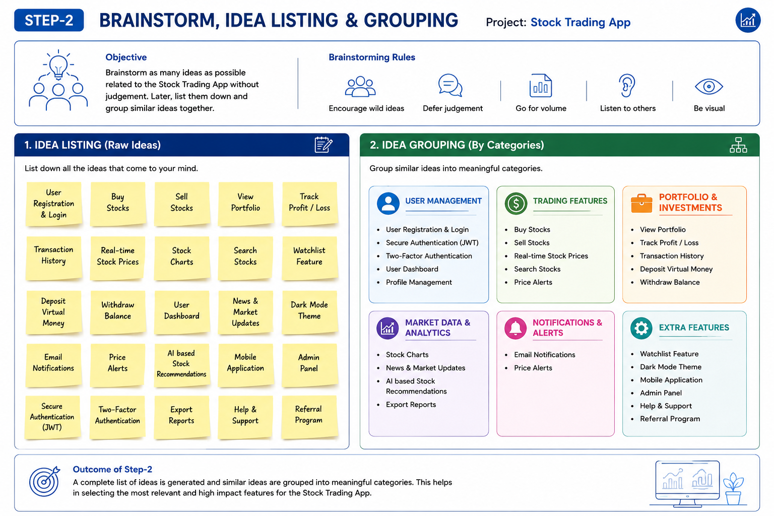

Step-3: Idea Prioritization
